

GoldenEye

Prepared By:
Hamza Jad Allah - 22110444
Suhaib Alajami - 22110069
Omar Malkawi - 22110244

Supervised By:
Dr. Rami Al-Ouran

Project Submitted in partial fulfillment for the degree of Bachelor of Science in Data Science & Artificial Intelligence

Spring-2025
Table of Contents
1. Application Description 5
1. Brief overview about the application 5
2. Produce detailed diagrams or models with all components/elements labeled. (M3) 6
Figure 1: GoldenEye System Architecture 6
Figure 2: YOLOv8n Training and Evaluation Pipeline 7
Figure 3: GoldenEye Inference Workflow 8
Figure 4: Use Case Diagram 8
Figure 5: Deployment Component Model 9
3. Describe the different stages involved in the project implementation. (P5) 10
Stage 8: Edge Deployment Preparation 13
2. Test Plan 14
1. Explain the testing procedures and validation plans for the project/application. (M5) 14
Testing Scope 14
Dataset Used for Testing 15
Final Model Test Evaluation 15
Manual Application Testing 16
Validation Plan 17
2. Analyze the implementation results and collected data to optimize performance. (D2) 18
Validation vs Test Comparison 18
Analysis of Detection Accuracy 18
Manual Interface Testing Analysis 19
Identified Bottlenecks and Issues 19
Optimization Decisions Made During Implementation 21
Recommended Future Optimizations 21
3. Reflection 22
1. Evaluate the project/application performance based on the required objectives, specifications, and implementation outcomes. (D3) 22
Evaluation Against Functional Requirements 24
Evaluation Against Non-Functional Requirements 24
Strengths of the Final Implementation 25
Limitations and Challenges 26
Improvements and Future Work 26
Overall Reflection 27
4. Files to be submitted 28
1. Implement the selected project using appropriate computing tools and methodologies (e.g., software development, simulation, and/or experimental). (P4, M4) 28
Final Model File 29
2. Discuss the process and results of your project through a professional presentation. (P7) 29
References 29

Table of Figures
Figure 1: GoldenEye system architecture showing data flow from input acquisition to detection output and edge deployment target. 6
Figure 2: YOLOv8n training and evaluation pipeline from dataset preparation to final test evaluation. 7
Figure 3: GoldenEye inference workflow used by the live interface to process visual input and display human detections. 7
Figure 4: Use case diagram showing how the rescue operator interacts with the GoldenEye detection system. 8
Figure 5: Deployment component model showing the target hardware and application components for edge-based search and rescue detection. 8
Figure 6 16

Table of Tables
Table 1 11
Table 2 12
Table 3 14
Table 4 15
Table 5 18
Table 6 21
Table 7 21
Table 8 23
Table 9 24
Table 10 24
Table 11 28
Table 12 29

Application Description

Brief overview about the application
GoldenEye: an AI-based, aerial drone-view human detection system aimed at assisting search and rescue operations in desert scenarios The system is designed for top-down and high-oblique perspectives of human detection, often in the unmanned aerial vehicle surveillance. The application is primarily used for helping the rescue teams to visualize vast open desert areas at less time and effort, in addition, the application identification of suspected injured or missing attributed humans are faster.
The project stemmed from a problem identified in the Capstone 1 Report, where it is described how ground search and rescue missions in desert and remote area environments were slow, expensive and challenging due to factors such as terrain, visibility, area size, and practical communications weak or non-existent. To remedy that, GoldenEye utilizes a computer vision pipeline that performs human detection on aerial desert images with a compact deep learning object detection model.
The implemented system uses a YOLO-based object detection approach, specifically YOLOv8n, because it provides a strong balance between detection accuracy, inference speed, model size, and suitability for edge deployment. Initial experiments were conducted using public search-and-rescue datasets to compare different YOLO model sizes. Based on these experiments, YOLOv8n was selected because it showed suitable performance for small human targets while maintaining low latency. The selected model was then fine-tuned using a private desert search-and-rescue dataset designed for Middle Eastern desert environments.
The last model is detecting a single object class, human. At each detected people, it outputs a bounding box and a score. These outputs help the operator visually locate detected humans in an image or frame of video. This aids in making faster decisions during the time of rescue and decreases reliance on individual monitoring of frames
The implemented application includes the following main capabilities:
- Detecting humans from aerial desert images.
- Supporting drone-view and vertical-view perspectives.
- Displaying bounding boxes around detected humans.
- Showing confidence scores for each detection.
- Supporting model evaluation using standard object detection metrics.
- Preparing the model for practical inference and edge deployment.
- Supporting search-and-rescue use cases where fast detection and low latency are important.
The system was developed using Python, Ultralytics YOLO, PyTorch, GPU resources, and a private desert dataset. The final model was trained and evaluated using a Tesla T4 GPU environment, while the system design also considers deployment on Raspberry Pi 5 with AI acceleration as part of the edge-computing objective.
GoldenEye does not replace rescue teams or emergency decision-making. Instead, it acts as an intelligent support tool that assists rescue operators by automatically identifying possible human targets from aerial imagery. This makes the system useful as a proof-of-concept for AI-assisted desert search and rescue operations.

2. Produce detailed diagrams or models with all components/elements labeled. (M3)

Figure 1: GoldenEye System Architecture
The system architecture diagram shows the overall structure of the GoldenEYE application. The system starts with input sources such as drone camera frames, uploaded images or videos, and screen-share input. These frames are passed into the preprocessing module, where they are resized and normalized before being processed by the YOLOv8n detection model.
The YOLOv8n model performs human detection and predicts bounding boxes around possible human targets. After inference, the postprocessing module applies confidence filtering and non-maximum suppression to remove weak or duplicate detections. The final output is displayed through the interface using bounding boxes and confidence scores.
The diagram also shows the training and evaluation environment, where the model was trained and tested using Kaggle GPU resources and the Ultralytics YOLO framework. The selected model artifact is the best.pt file, which represents the best trained model weights. The diagram also includes the edge deployment target, which is Raspberry Pi 5 with AI acceleration for future or practical deployment.
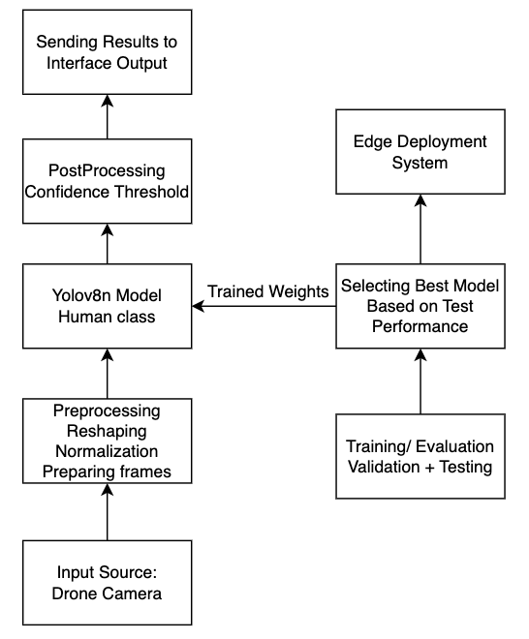
Figure 1: GoldenEye system architecture showing data flow from input acquisition to detection output and edge deployment target.

Figure 2: YOLOv8n Training and Evaluation Pipeline
The training and evaluation pipeline diagram shows how the final detection model was developed. The process begins with the private desert search-and-rescue dataset obtained from the Shaheen project. The dataset was organized in YOLO format, including image files, label files, and a data.yaml configuration file.
The dataset was divided into training, validation, and testing subsets. The training set was used to fine-tune the YOLOv8n model, while the validation set was used to monitor performance and select the best model weights. Data augmentation was applied during training to improve the model’s robustness against variations in lighting, position, scale, and movement.
After training, the best model was selected based on validation performance. The final selected model was then evaluated on the unseen test set. The final test result achieved 0.975 precision, 0.985 recall, 0.979 mAP50, and 0.626 mAP50-95.
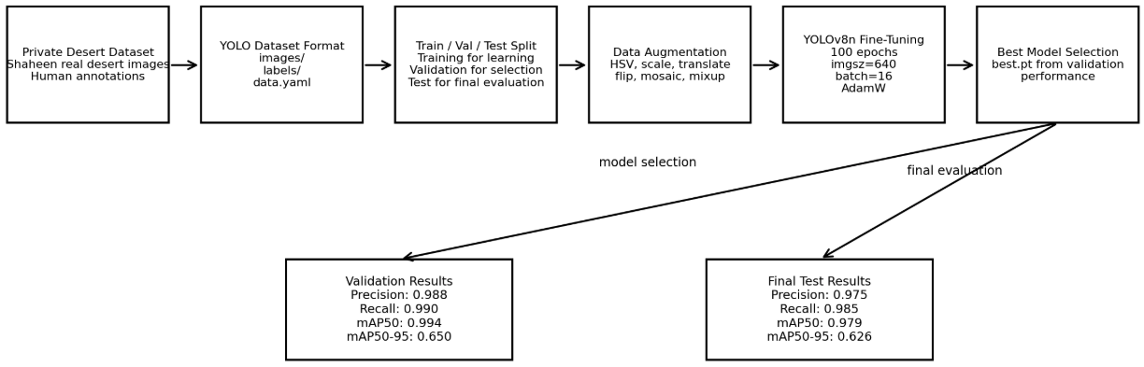
Figure 2: YOLOv8n training and evaluation pipeline from dataset preparation to final test evaluation.

Figure 3: GoldenEye Inference Workflow
The inference workflow diagram explains how the application processes a new input frame. The input can come from a live camera, screen-share input, image, or video. The frame is captured and passed into the preprocessing stage, where it is resized and normalized for YOLOv8n inference.
The YOLOv8n model then predicts human detections. The postprocessing stage filters detections using confidence thresholds and non-maximum suppression. The final output is displayed in the operator interface with the human label, bounding box, and confidence score.
This workflow is important because it shows that GoldenEye is not only a trained model but also a practical inference pipeline that can process visual input and return useful detection results.
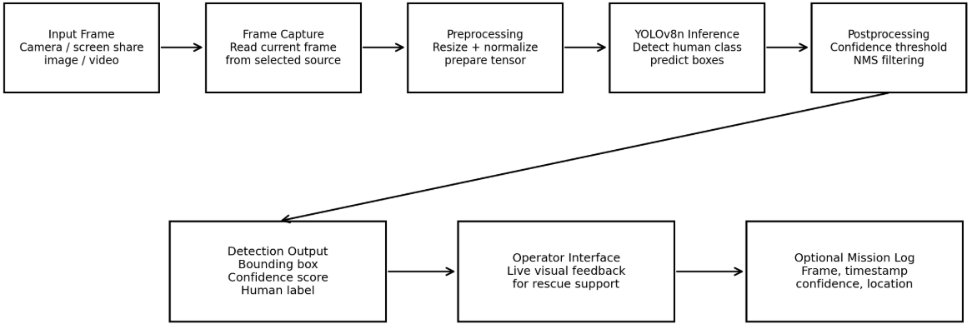
Figure 3: GoldenEye inference workflow used by the live interface to process visual input and display human detections.

Figure 4: Use Case Diagram
The use case diagram shows how the rescue operator interacts with the GoldenEYE system. The main actor is the rescue operator, who uses the system to select the input source, load the trained model, run human detection, view bounding boxes and confidence scores, evaluate model metrics, and save evidence for the report or demonstration.
This diagram shows the user-facing functionality of the system and confirms that the application was designed to support practical search and rescue workflows.
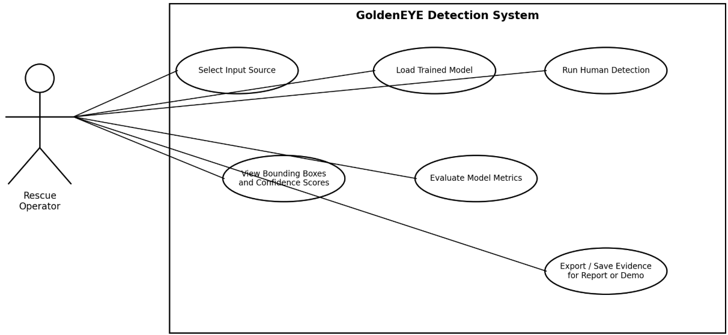
Figure 4: Use case diagram showing how the rescue operator interacts with the GoldenEye detection system.

Figure 5: Deployment Component Model
The deployment component model shows the intended hardware and software components for practical deployment. The system receives aerial RGB frames from a camera or drone-view input. The Raspberry Pi 5 acts as the main controller responsible for frame handling and application execution. The AI acceleration component is used as the target for optimized inference. The GoldenEYE application performs detection logic and visualization.
The output of the deployment model is a detection result containing the human label, confidence score, and bounding box. This result can support rescue operators through visual alerts, screenshots, and optional GPS logging in future development.
This diagram supports the edge-computing objective of the project and shows how the trained model can be integrated into a practical deployment environment.
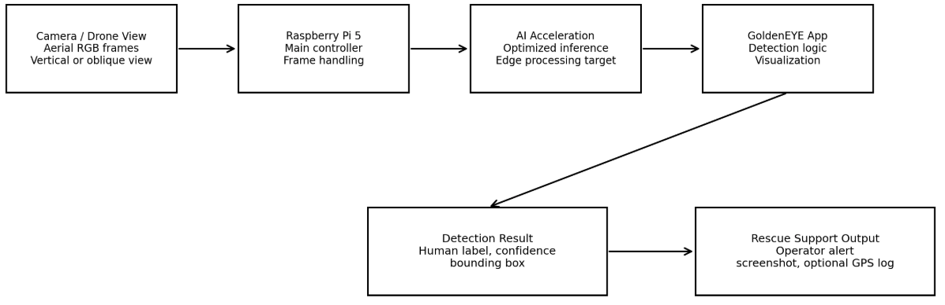
Figure 5: Deployment component model showing the target hardware and application components for edge-based search and rescue detection.

3. Describe the different stages involved in the project implementation. (P5)
The implementation of GoldenEye was completed through a structured set of stages. Each stage contributed to building, testing, and improving the final detection system.
Stage 1: Problem Definition and Requirement Analysis
In the first phase, this involves defining the search-and-rescue problem and specifying system requirements. But the big problem was in finding humans from air image in huge desert backgrounds. A model that could spot small human targets in extremely challenging visual conditions (low contrast, sand-colored backgrounds, excellent lights, and top-down viewpoints) was required for this.
The main functional requirements were:
- Detect humans from aerial drone-view images.
- Display bounding boxes and confidence scores.
- Support real-time or near real-time inference.
- Work with desert-specific visual conditions.
- Be suitable for future edge deployment.
The main non-functional requirements were:
- High detection accuracy.
- Low inference latency.
- Lightweight model size.
- Compatibility with limited hardware resources.
- Reliable performance on unseen desert images.
Stage 2: Dataset Preparation
The second step was preparing the data used for training and validating the model. The last dataset which reflects the fine-tuning set, is the private desert search and rescue, obtained from Shaheen project. It is composed of aerial desert images targeted for human observation in the Middle Eastern arid lands.
The dataset contained humans in various appearances, clothing colors, poses and movements under different background conditions. This variety was significant, since people in real search and rescue situations can be small or partially occluded, and their appearance could be like that of the surrounding sand.
Since YOLO dataset format was used, a label file containing bounding box annotations for human class was created for each image. To promote appropriate model training and final evaluation, the data was split into train/validation/test subsets.
Stage 3: Baseline Model Testing and Model Selection
Using a universal search-and-rescue dataset, different YOLO model sizes were explored before constructing the final trainable estimate. This stage was aimed to determine which model offered the best trade-off between accuracy and speed.
Although bigger models can deliver better detection performance, they are usually computationally expensive and unsuitable for edge deployment. It may lead to loss of accuracy when the task is complex, so smaller models can be faster and lighter. GoldenEye is designed for practical deployment with low-latency inference, so model efficiency was a key design consideration.
With the baseline experiments, the final model architecture was chosen to be YOLOv8n. The nano version was eventually selected because it is lightweight, extremely fast and able to detect small objects while still being feasible for edge-computing environments.
Stage 4: Model Fine-Tuning
After selecting YOLOv8n, the model was fine-tuned on the private desert dataset. Fine-tuning allowed the model to adapt from general object detection knowledge to the specific task of detecting humans in desert aerial imagery.
The training configuration included:
Table 1
Parameter | Value
Model | YOLOv8n
Epochs | 100
Image Size | 640
Batch Size | 16
Optimizer | AdamW
Initial Learning Rate | 0.001
Weight Decay | 0.0005
Patience | 20
Framework | Ultralytics YOLO
Training Environment | Kaggle GPUs

Data augmentation was also applied to improve model robustness. The augmentation settings included changes to color, scale, translation, horizontal flipping, mosaic augmentation, and mixup. These techniques helped the model generalize better to different desert lighting conditions, human positions, and visual variations.
Stage 5: Model Validation
During and after training, the model was validated using the validation split. Validation was used to monitor whether the model was learning effectively and to select the best model weights.
The best validation result achieved:
Table 2
Metric | Result
Validation Images | 706
Human Instances | 343
Precision | 0.988
Recall | 0.990
mAP50 | 0.994
mAP50-95 | 0.650
Inference Time | 3.0 ms/image

These results showed that the model learned the target class effectively and achieved strong detection performance on the validation data.
Stage 6: Final Test Evaluation
The final performance of the best model is tested on unseen data, namely on the test set after validation. The reason test results are a final important stage in the data science workflow is that they offer a realistic estimate of how the model performs in live conditions beyond training or validation.
The test set had 1411 images and 688 human instances The high precision and recall of the model demonstrate that it was able to detect most human targets whilst keeping false detections low.
Final testing results will be discussed further in the Test Plan and Reflection sections of this report.
Stage 7: Inference Application Development.
After training and testing the model, the detection system was prepared for practical inference. The inference application uses the trained YOLOv8n model to process input images or frames and display detection results.
The application performs the following steps:
- Receives an image or video frame.
- Preprocesses the input.
- Runs YOLOv8n inference.
- Applies confidence filtering and postprocessing.
- Draws bounding boxes around detected humans.
- Displays confidence scores to the user.
This stage converted the trained model from an experimental notebook result into a usable detection system.

Stage 8: Edge Deployment Preparation
As the project is targeted towards drone based search and rescue, part of implementation was also edge deployment. Model selection: YOLOv8n (3m Parameters), a small and compact model better suited for embedded deployment compared to larger YOLO models.
The system has been ready for deployment on Raspberry Pi 5 with AI's acceleration. This aligns with the project goal to be able to run human detection nearer to the drone camera without relying entirely on the cloud processing. The main quantitative model evaluation described in this document was actually performed on the Kaggle Tesla T4 GPU environment. If benchmarking Raspberry Pi has been done, any results regarding the performance of embedded hardware should be reported separately.
Stage 9: Documentation and Final Report Preparation
The final stage involved organizing the implementation work into formal project deliverables. This included preparing the technical report, documenting the model training and testing process, organizing the source code, preparing the final presentation, and collecting evidence for the final project demonstration.
This stage ensures that the project is not only implemented but also properly documented, reproducible, and ready for academic evaluation.

2. Test Plan

Explain the testing procedures and validation plans for the project/application. (M5)
The testing phase of GoldenEye was conducted to verify that the implemented system works correctly as both a machine learning detection model and a usable search-and-rescue application. The testing process was divided into two main categories: model-level testing and application-level manual testing.
Model-level testing was conducted through the Python training and evaluation notebook using the Ultralytics YOLO framework. This part measured the quantitative performance of the final YOLOv8n model using validation and test datasets. Application-level testing was conducted manually using the developed live inference interface, which supports both camera input and screen-share input. This manual testing verified that the trained model could be used inside a functional application and not only inside a notebook environment.
The main objectives of the testing phase were:
- To verify that the YOLOv8n model can detect humans from aerial desert imagery.
- To evaluate the final model using standard object detection metrics.
- To confirm that the model generalizes to unseen validation and test images.
- To measure the speed of the model during inference.
- To verify that the system can display bounding boxes and confidence scores.
- To test the live interface using camera input.
- To test the live interface using screen-share input.
- To identify weaknesses, bottlenecks, and possible improvements.

Testing Scope
The testing scope covered both the AI model and the final application.
Table 3
Testing Area | Description
Dataset validation | Checked whether the dataset images and labels were readable and correctly structured.
Model validation | Evaluated the trained model on the validation split to select the best model weights.
Final model testing | Evaluated the best model on the unseen test split.
Detection output | Verified that the model produces bounding boxes and confidence scores.
Background handling | Tested images without humans to check false detections.
Small-object detection | Tested whether the system can detect humans from drone-view images where people appear small.
Inference speed | Measured preprocessing, inference, and postprocessing time per image.
Live interface testing | Manually tested the application using camera and screen-share input.
Usability testing | Checked whether the interface is understandable and usable for demonstration purposes.

Dataset Used for Testing
The final model was fine-tuned and evaluated using a private desert search-and-rescue dataset obtained from the Shaheen project. The dataset was designed for Middle Eastern desert environments and contains aerial images with desert backgrounds, different human appearances, different clothing colors, different poses, and different movement conditions.
The dataset was organized in YOLO format, where each image has an associated label file containing the bounding box annotation for the human class. The dataset was split into training, validation, and testing subsets. The validation set was used to select the best model weights, while the test set was used for the final performance evaluation.
The presence of background images is important because it tests whether the model incorrectly detects humans in images where no person exists. This is important for search and rescue applications because excessive false alarms can reduce operator trust and waste response time.

Final Model Test Evaluation
After validation, the best model was evaluated on the unseen test set. This was the most important quantitative test because the test images were not used to train the model or select the best weights.
The final test result was:
Table 4
Metric | Final Test Result
Images | 1411
Human Instances | 688
Background Images | 763
Precision | 0.975
Recall | 0.985
F1 Score | 0.980
mAP50 | 0.979
mAP50-95 | 0.626
Preprocessing Time | 0.6 ms/image
Inference Time | 2.7 ms/image
Postprocessing Time | 0.5 ms/image
Total Processing Time | 3.8 ms/image
The final test results confirm that GoldenEYE achieved strong detection performance on unseen aerial desert images. The model achieved 97.5% precision, 98.5% recall, and 97.9% mAP50. These results show that the system is effective at detecting humans while maintaining a low number of false detections and missed detections.
The recall score is especially important because the project is related to search and rescue. In this domain, missing a human target is more critical than producing an occasional false alarm. Therefore, the high recall value of 0.985 is one of the strongest outcomes of the final implementation.
The model also achieved low processing time in the Kaggle Tesla T4 environment. The total processing time was
0.6+2.7+0.5=3.8 ms/image
The estimated GPU-side processing speed is:
FPS=3.81000​=263.16
Therefore, the model achieved an estimated processing speed of approximately 263 FPS on the Tesla T4 GPU environment. This value represents GPU-side evaluation speed and should not be reported as Raspberry Pi or drone deployment speed unless separate embedded benchmarking results are provided.

Manual Application Testing
In addition to the notebook-based model evaluation, manual testing was conducted using the live GoldenEYE interface. This was necessary to verify that the trained model was integrated into a working application and could process real input sources.
The manual tests were conducted using two input modes:
- Camera input test
- Screen-share input test
The camera input test verified that the application could receive live frames from a camera, pass them to the detection model, and display results visually. The screen-share input test verified that the application could analyze frames from a shared screen or selected display. This was useful for testing recorded drone footage, simulation videos, or dataset samples displayed on screen.
Manual testing was important because notebook metrics alone do not prove that the final application is usable. The live interface confirmed that the model can be used in a practical workflow where frames are received, processed, and displayed with bounding boxes and confidence scores.
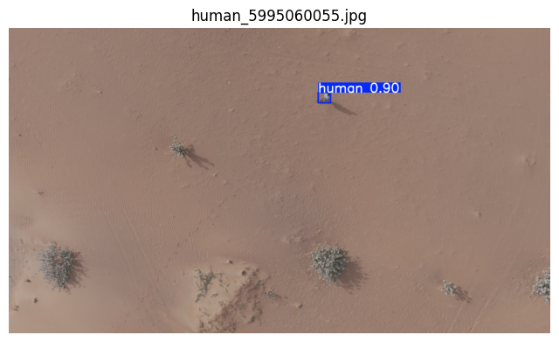
Figure 6

Validation Plan
The validation plan was designed to ensure that the model and application were tested in a structured way. The validation process followed these steps:
- Prepare the dataset in YOLO format.
- Train YOLOv8n on the prepared desert dataset.
- Monitor validation metrics during training.
- Select the best model weights based on validation performance.
- Evaluate the best model on the unseen test split.
- Record precision, recall, mAP50, mAP50-95, and speed values.
- Test the trained model inside the live inference interface.
- Manually verify camera input.
- Manually verify screen-share input.
- Capture screenshots as evidence of functional testing.
- Analyze the results and identify optimization opportunities.
This validation plan confirms that the project was tested from both a machine learning perspective and an application functionality perspective.

Analyze the implementation results and collected data to optimize performance. (D2)
The implementation results show that GoldenEye achieved strong performance for the main task of detecting humans from aerial desert imagery. The final YOLOv8n model achieved high precision, high recall, high mAP50, and low inference latency.
The strongest result is the final test mAP50 of 0.979, which means the model achieved the original high-level detection target when evaluated at the 0.5 IOU threshold. The final test recall of 0.985 is also highly important because search-and-rescue systems must minimize missed detections. A missed detection may represent a missed person in an operational rescue scenario, so recall is one of the most important metrics for this project.
The model also achieved a final test precision of 0.975, showing that most detections were correct. This is important because false positives can waste operator time and reduce trust in the system. The balance between high precision and high recall shows that the model is not only detecting most human targets but is also avoiding many incorrect detections.

Validation vs Test Comparison
Table 5
Metric | Validation Result | Test Result | Difference
Precision | 0.988 | 0.975 | -0.013
Recall | 0.990 | 0.985 | -0.005
F1 Score | 0.989 | 0.980 | -0.009
mAP50 | 0.994 | 0.979 | -0.015
mAP50-95 | 0.650 | 0.626 | -0.024
Total Processing Time | 4.4 ms/image | 3.8 ms/image | 0.6 ms faster on test
The difference between validation and test performance is small. Precision decreased by 0.013, recall decreased by 0.005, and mAP50 decreased by 0.015. This indicates that the model generalized well to unseen test data and did not show a severe overfitting problem.
The mAP50-95 score decreased from 0.650 to 0.626. This confirms that strict localization remains the main area for improvement. The model can detect humans reliably, but the exact bounding box alignment is less accurate under stricter IoU thresholds.

Analysis of Detection Accuracy
The final test mAP50 value of 0.979 shows that GoldenEYE is highly effective at detecting human targets in the tested desert dataset. This result is strong because the target class is visually difficult in aerial desert imagery. Humans may appear small, partially occluded, or similar in color to the sand background.
The high recall value of 0.985 shows that the model successfully detected most human instances. This is a critical result because the project is designed for search and rescue support. In this context, recall is more important than precision because missing a victim is more serious than producing a false alarm.
The high precision value of 0.975 shows that the model also controls false detections. This is useful for real rescue operators because a system with too many false alarms can reduce trust and slow down the response.
Overall, the detection results show that the model is suitable as a strong proof-of-concept for AI-assisted human detection in desert search-and-rescue scenarios.

Manual Interface Testing Analysis
Manual interface testing confirmed that the project was implemented as a functional application. The live interface was tested with camera input and screen-share input. These tests showed that the trained model could be used outside the notebook to process live visual input and display detection outputs.
The camera input test is important because the final search-and-rescue concept depends on receiving frames from a visual sensor. The screen-share input test is also useful because it allows the system to process drone footage, simulation videos, or dataset samples displayed on screen. This makes the application flexible for demonstrations and testing when direct drone input is not available.
The manual testing confirmed the following:
- The model can be loaded into the application.
- The interface can receive live visual input.
- The system can process frames using the trained model.
- The system can display bounding boxes.
- The system can display confidence scores.
- The system can support demonstration and showcase testing.
The manual tests support the functional application requirement because they prove that GoldenEye is not only a trained model but also a working application interface.

Identified Bottlenecks and Issues
The testing process identified several important limitations and bottlenecks.
1. Bounding Box Localization:
The main technical limitation is the difference between mAP50 and mAP50-95. The model achieved 0.979 mAP50, but only 0.626 mAP50-95 on the test set. This means the model detects humans successfully, but bounding box precision decreases under stricter IoU thresholds.
This is expected in drone-view human detection because humans often appear very small. When an object is small, even a slight bounding box shift can cause a large decrease in IoU.
Optimization:
Use higher image sizes, improve annotation quality, or apply image slicing methods such as SAHI for high-resolution drone footage.
2. Small Object Detection:
Humans in aerial images may occupy a small number of pixels, especially when the drone camera is high above the ground. This makes detection more difficult and affects localization accuracy.
Optimization:
Train and test with larger image sizes such as 960 or 1280. Another option is to use tiled inference, where large images are divided into smaller regions before detection.
3. Domain Generalization:
The final model was trained and tested on a private desert dataset. This improves performance for similar desert environments, but it does not guarantee equal performance in all desert regions or all weather and lighting conditions.
Optimization:
Add more real-world data from different desert locations, different altitudes, different camera angles, and different lighting conditions.
4. Embedded Hardware Benchmarking:
Although the model is lightweight, most quantitative speed results were measured on a Tesla T4 GPU. This does not directly represent Raspberry Pi 5 or AI HAT performance.
Optimization:
Run a separate embedded benchmark measuring FPS, latency, CPU usage, memory usage, temperature, and stability during continuous operation.
5. Interface Error Handling:
The live interface was manually tested using camera and screen-share input. However, additional testing is needed for invalid input sources, missing camera permissions, disconnected cameras, and long-duration operation.
Optimization:
Add stronger error handling, user messages, logging, and automatic recovery when the input source fails.

Optimization Decisions Made During Implementation
Several optimization decisions were made during development to improve system performance and practicality.
Table 6
Optimization Decision | Reason
YOLOv8n was selected | It provides a strong balance between accuracy, latency, and edge deployment suitability.
Larger YOLO models were not selected as final model | Larger models may increase latency and reduce suitability for Raspberry Pi deployment.
AdamW optimizer was used | It supports stable training and regularization.
Data augmentation was applied | It improves robustness to lighting, scale, movement, and visual variation.
Early stopping patience was used | It reduces unnecessary training and helps avoid overfitting.
Validation and test splits were separated | This provides a more reliable evaluation of model generalization.
Manual live interface testing was conducted | This verifies that the model works inside a functional application.
Camera and screen-share inputs were supported | This improves flexibility for testing, demonstration, and future deployment.

Recommended Future Optimizations
Table 7
Area | Recommended Improvement
Localization accuracy | Improve annotation quality and train with larger image size.
Dataset diversity | Add more real aerial data from different Middle Eastern desert regions.
Live application stability | Add stronger error handling for camera failure and screen-capture failure.
Operator usability | Add clearer alerts, detection confidence controls, and exportable logs.
Long-duration testing | Test the system continuously to measure stability, memory usage, and temperature.

The testing process confirmed that GoldenEYE works as both a trained object detection model and a functional application. The Python notebook evaluation showed that the final YOLOv8n model achieved strong performance on the private desert test dataset, with 0.975 precision, 0.985 recall, 0.979 mAP50, and 0.626 mAP50-95. The model also achieved a low inference time of 2.7 ms per image.
Manual testing using the live interface confirmed that the system can process camera input and screen-share input, display bounding boxes, and show confidence scores. This supports the conclusion that the project was practically implemented as a working application.
The main limitation is strict bounding box localization, shown by the lower mAP50-95 score. Future work should focus on larger image sizes, image slicing, additional desert datasets, embedded hardware benchmarking, and stronger interface error handling. Overall, the testing results show that GoldenEYE successfully meets the main detection objective and provides a strong foundation for AI-assisted search and rescue in desert environments.

3. Reflection

Evaluate the project/application performance based on the required objectives, specifications, and implementation outcomes. (D3)
The GoldenEYE project was implemented to support search and rescue operations in desert environments by detecting humans from aerial drone-view imagery. The main objective was to build an AI-based detection system that can identify humans from top-down and high-oblique perspectives, especially in Middle Eastern desert environments where visual conditions can be difficult due to sand-colored backgrounds, low contrast, harsh sunlight, and small object size.
The final implemented system successfully achieved the core functional objective of detecting humans in aerial desert images. The system uses a YOLOv8n object detection model trained and fine-tuned for one target class: human. The model produces bounding boxes and confidence scores around detected humans, allowing the operator to visually identify possible victims or missing individuals in the input frame.
The final model was evaluated on an unseen test set containing 1,411 images, including 688 human instances and 763 background images. The model achieved the following final test results:
Table 8
Metric | Final Test Result
Precision | 0.975
Recall | 0.985
F1 Score | 0.980
mAP50 | 0.979
mAP50-95 | 0.626
Preprocessing Time | 0.6 ms/image
Inference Time | 2.7 ms/image
Postprocessing Time | 0.5 ms/image
Total Processing Time | 3.8 ms/image

These results show that the system achieved strong detection performance. The precision score of 0.975 means that most detections produced by the model were correct. This is important because false detections can distract rescue operators and reduce trust in the system. The recall score of 0.985 is especially important for search and rescue applications because missed detections are more dangerous than false alarms. In a real rescue scenario, failing to detect a missing person could have serious consequences. Therefore, the high recall score indicates that the model is suitable for the main objective of locating humans in aerial desert imagery.
The model also achieved a mAP50 score of 0.979, which means that the system met the original high-level detection target when evaluated using the 0.5 IoU threshold. This confirms that the model is highly capable of detecting humans in the tested desert dataset. However, the mAP50-95 score of 0.626 shows that the model’s bounding box localization accuracy still needs improvement under stricter IoU thresholds. This means that although the model can detect humans reliably, the exact alignment of the bounding boxes around the human target is not always highly precise.
This difference between mAP50 and mAP50-95 is expected in aerial human detection because humans often appear very small in drone-view images. When the target is small, even a minor shift in the bounding box can significantly reduce the IoU score. Therefore, the lower mAP50-95 result does not mean that the system failed to detect humans; rather, it indicates that localization precision can be further improved.
From a performance perspective, the model achieved very low inference latency on the Kaggle Tesla T4 GPU environment. The reported inference time was 2.7 ms per image, with a total processing time of 3.8 ms per image including preprocessing and postprocessing. This corresponds to an estimated GPU-side processing speed of approximately 263 FPS. This result demonstrates that the selected YOLOv8n model is computationally efficient and suitable for real-time or near real-time detection workflows.
However, this GPU result should not be confused with final embedded hardware performance. The Tesla T4 GPU is significantly more powerful than Raspberry Pi 5 or similar edge devices. Therefore, while the model is lightweight and suitable for edge deployment, separate benchmarking is required to report exact Raspberry Pi 5 / AI HAT FPS, CPU usage, memory usage, and temperature behavior.
Overall, the implemented application met the main functional requirements of the project. It can detect humans from aerial desert imagery, generate bounding boxes, provide confidence scores, and support fast inference. The non-functional requirements were also partially met. The model achieved high accuracy and low GPU latency, and the use of YOLOv8n supports the requirement for lightweight deployment. However, additional work is still required to fully validate long-duration edge deployment, real drone flight integration, GPS logging, and field operation under uncontrolled environmental conditions.

Evaluation Against Functional Requirements
Table 9
Requirement | Evaluation
Detect humans from aerial imagery | Achieved. The final model detects humans from drone-view desert images.
Support top-down and high-oblique perspectives | Achieved. The dataset and target use case focus on aerial perspectives.
Provide bounding boxes | Achieved. The YOLOv8n model outputs bounding boxes around detected humans.
Provide confidence scores | Achieved. Each detection includes a confidence value.
Support real-time or near real-time inference | Achieved on GPU. Embedded performance requires separate benchmarking.
Work in desert-specific visual conditions | Achieved on the tested private desert dataset. More field testing is needed for broader generalization.
Reduce manual monitoring effort | Achieved conceptually. The system automatically highlights possible human targets.
Support search and rescue decision-making | Partially achieved. The detection system supports decision-making, but full mission-level integration requires GPS and drone-control validation.

Evaluation Against Non-Functional Requirements
Table 10
Requirement | Evaluation
High detection accuracy | Achieved. The model reached 0.979 mAP50 on the test set.
High recall to reduce missed detections | Achieved. The model reached 0.985 recall on the test set.
Low inference latency | Achieved on GPU. The model reached 2.7 ms inference time per image on Tesla T4.
Lightweight model size | Achieved. YOLOv8n has approximately 3 million parameters.
Edge deployment suitability | Partially achieved. YOLOv8n is suitable for edge deployment, but embedded benchmarking must be documented separately.
Stability during long operation | Not fully validated. Long-duration operational testing is still required.
Robustness under all desert conditions | Partially achieved. The model was tested on desert imagery, but more diverse field testing is needed.
Easy operation by non-technical users | Partially achieved. Detection outputs are simple to interpret, but the final interface usability still needs user testing.

Strengths of the Final Implementation
The final implementation has several important strengths.
First, the system achieved very high detection performance on the final test set. The mAP50 score of 0.979 and recall score of 0.985 show that the model is highly capable of identifying humans in the tested aerial desert imagery. This is a strong result for the core search and rescue objective.
Second, the selected YOLOv8n model provides an effective balance between accuracy and speed. Larger models may achieve slightly better accuracy, but they require more computational resources and may not be practical for edge deployment. YOLOv8n was selected because it is lightweight, fast, and suitable for future deployment on embedded platforms such as Raspberry Pi 5 with AI acceleration.
Third, the project used a desert-specific private dataset instead of relying only on general object detection datasets. This improved the relevance of the model to the intended operational environment. Desert imagery creates specific challenges such as low contrast, sand-colored backgrounds, shadows, and small target appearance. Fine-tuning on a desert-specific dataset helped the model adapt to these conditions.
Fourth, the implementation followed a proper machine learning workflow. The model was trained, validated, and finally tested on unseen data. This separation between validation and test evaluation makes the reported results more reliable than reporting training accuracy only.
Finally, the system is practical as a proof-of-concept. It demonstrates that AI-based human detection from drone-view desert imagery is technically feasible and can support future search and rescue applications.

Limitations and Challenges
Although the project achieved strong results, several limitations remain.
The first limitation is bounding box localization accuracy. The model achieved a high mAP50 score, but the mAP50-95 score was lower. This indicates that the model detects humans successfully but does not always produce highly precise bounding boxes under stricter localization thresholds. This issue is common in small-object detection because aerial human targets may occupy only a small number of pixels.
The second limitation is dataset dependency. The final model was fine-tuned and evaluated using a private desert dataset. While this improves performance for similar environments, it does not guarantee the same performance in all deserts or all real-world conditions. Different sand colors, camera altitudes, lighting conditions, clothing types, and human poses may affect performance.
The third limitation is that final quantitative benchmarking was performed on a Kaggle Tesla T4 GPU. Although this is useful for measuring model performance, it does not fully represent performance on Raspberry Pi 5 or other embedded devices. Embedded deployment may introduce additional latency from camera capture, preprocessing, memory transfer, power limitations, and thermal constraints.
The fourth limitation is that the project mainly validates the AI detection component. A complete operational rescue drone system would also require reliable GPS logging, flight control integration, battery-aware mission planning, communication handling, and safety validation. These parts are outside the current implementation scope or require additional field testing.
The fifth limitation is that real-world SAR scenarios can be more complex than dataset testing. Missing persons may be partially covered by sand, hidden behind rocks, lying down, wearing sand-colored clothing, or appearing under extreme lighting conditions. More real-world testing is required before the system can be considered ready for operational deployment.

Improvements and Future Work
Several improvements can be made to strengthen GoldenEye in future development.
First, the model should be trained and evaluated using larger input image sizes, such as 960 or 1280 pixels. This may improve small-object detection and bounding box localization because more visual detail is preserved during inference.
Second, additional datasets should be added from different desert environments. This would improve model generalization and reduce dependency on one dataset source. Data should include different sand colors, shadows, clothing types, camera angles, human poses, and weather conditions.
Third, the system should be benchmarked directly on Raspberry Pi 5 with the AI HAT. The benchmark should measure FPS, latency, CPU usage, memory usage, temperature, and stability over extended operation. These results are necessary to prove practical edge deployment.
Fourth, the application should be extended with GPS coordinate logging. When a human is detected, the system should record the frame, timestamp, confidence score, and GPS location. This would make the system more useful for real search and rescue missions.
Fifth, the user interface should be improved for rescue operators. The interface should include simple controls, clear detection alerts, confidence thresholds, image/video input options, and an exportable detection log.
Finally, controlled field testing should be conducted using real drone footage. Field testing would provide stronger evidence of system reliability under real lighting, altitude, motion, and environmental conditions.

Overall Reflection
GoldenEYE successfully demonstrates the implementation of an AI-based human detection system for desert search and rescue. The project moved from a proposed concept in Capstone 1 into a working Capstone 2 implementation with a trained YOLOv8n model, desert-specific fine-tuning, quantitative evaluation, and practical inference preparation.
The most successful part of the project was the detection performance. The final model achieved 0.979 mAP50, 0.975 precision, and 0.985 recall on the test set. These results show that the system is highly effective at detecting humans in the tested aerial desert imagery. The high recall value is particularly important because search and rescue systems must minimize missed detections.
The main technical weakness is the lower mAP50-95 score of 0.626, which shows that strict bounding box localization still needs improvement. This does not remove the value of the system, but it clearly identifies the next area for optimization.
In conclusion, the final implementation meets the core objectives of the project as an AI detection system for desert SAR support. It provides strong evidence that lightweight YOLO-based models can be used to detect humans from drone-view imagery with high accuracy and low latency. However, before the system can be considered fully operational in real rescue missions, further work is required in embedded benchmarking, drone integration, GPS logging, and real-world field validation.

4. Files to be submitted

1. Implement the selected project using appropriate computing tools and methodologies (e.g., software development, simulation, and/or experimental). (P4, M4)
The project source code and implementation files will be submitted through the project repository. The repository includes the files required to reproduce the model training, testing, evaluation, and inference workflow.
Source code link:

The submitted source code includes the following components:
Table 11
File/Folder | Description
Training notebook/scripts | Code used to train and fine-tune the YOLOv8n model.
Evaluation notebook/scripts | Code used to validate and test the final model.
Dataset configuration file | YOLO data configuration file defining dataset paths and class names.
Model weights | Final trained YOLOv8n model weights.
Inference script/application | Code used to run detection on images, videos, or frames.
Requirements file | Python libraries required to run the project.
README documentation | Instructions explaining how to set up and run the project.
Results folder/screenshots | Evidence of model evaluation and detection outputs.
The implementation was completed using appropriate computing tools and methodologies, including Python, PyTorch, Ultralytics YOLO, Kaggle GPU resources, and object detection evaluation methods. The project followed an experimental machine learning workflow that included dataset preparation, model selection, training, validation, testing, result analysis, and optimization.
The functional application requirement was addressed by developing a working AI detection pipeline that accepts aerial imagery as input and produces bounding boxes and confidence scores for detected humans. This confirms that the project was not limited to theoretical design but was implemented as a working detection system.

Final Model File
The final selected model was YOLOv8n. The best model weights were saved after fine-tuning on the private desert dataset.
Final model path during training:
The model was selected because it provided the best balance between performance and efficiency. It achieved strong detection results while remaining lightweight enough for future edge deployment.
Table 12
Model Detail | Value
Model | YOLOv8n
Layers | 73
Parameters | 3,005,843
GFLOPs | 8.1
Class | Human
Task | Object Detection

2. Discuss the process and results of your project through a professional presentation. (P7)
The final presentation summarizes the project background, problem statement, objectives, methodology, implementation stages, testing results, limitations, and future work. It also explains the process followed by the team and presents the final detection outcomes.

References

